SIMULATION OF LONGITUDINAL ELECTRON COOLING OF 20 GeV PROTON BEAM AT EicC*
X. D. Yang†, He Zhao, Institute of Modern Physics, CAS, Lanzhou, China

Abstract
The longitudinal electron cooling processes of a 20 GeV proton beam were simulated using a code at the Electron-Ion collider in China. The longitudinal cooling time was obtained for different parameter configurations of the storage ring, proton beam, electron cooling device, and electron beam. From the simulated results, the longitudinal cooling time of the 20 GeV proton beam is over 100 seconds. The longitudinal cooling time can be shortened with the help of proper configuration of the parameters.

Introduction
Based on the HIAF (the Heavy Ion High-Intensity Accelerator Facility, approved in 2015 in China), a high luminosity polarized Electron-Ion Collider facility in China (EicC) was proposed to study hadron structure and the strong interaction to carry out the frontier research on both nuclear and particle physics.
EicC will be constructed in two phases, EicC-I and EicC-II. In the first phase, the proton beam with energy between 15~20 GeV will collide with the electron beam with energy between 2.8~5 GeV in the collider. Both electron and proton beams are polarized. The luminosity is expected to achieve 2~4×10³³ cm⁻²·s⁻¹.
In the second phase, the energy of the proton will be upgraded to 60~100 GeV, and the energy of the electron beam will increase to 5~10 GeV, the luminosity expected to reach 1×10³⁵. The primary design and some initial parameters of EicC will be found in the reference [1].
In order to obtain the expected luminosity in the collider, the polarized proton beam should be cooled by various cooling methods throughout the whole energy range. In the case of high-intensity energy proton beams especially, the intra-beam scattering effect should be taken into account in the collider design. The transverse electron cooling and intra-beam scattering were presented in the reference [2]. Some preliminary simulations of longitudinal electron cooling are presented in this contribution.

simulation of electron cooling
The longitudinal electron cooling time depends not only on the lattice parameters of the storage ring, such as the Betatron function, dispersion of the cooling section, parameters of proton beam including energy, initial emittance, and momentum spread, but also on the construction parameters of electron cooling device, including the strength of magnetic field, the parallelism of magnetic field in the cooling section, the effective cooling length, and the parameters of electron beam, such as radius, density and transverse temperature of electron beam. These parameters are determined by the storage ring and the technology limitation, on the other hand, they are influenced and restricted by each other.

* Work supported by NSFC No. 12275325, 12275323, 12205346.
† yangxd@impcas.ac.cn
Among these parameters, the first type of parameter determines whether the proton beam under such parameters can be cooled down, playing a decisive role. The second type of parameter determines the length of cooling time for the proton beam under such parameters, playing an optimization role.
Using the electron cooling simulation code SIMCOOL [3, 4], the longitudinal electron cooling time of the proton beam was extensively simulated in various parameters in the EicC, including proton beam energy, initial transverse emittance, and momentum spread. The influence of the machine lattice parameters such as the Betatron function and dispersion function the cooling time was investigated. The parameters of the electron beam and cooling devices were taken into account, such as effective cooling length, magnetic field strength and parallelism in the cooling section, and electron beam current.
The different performances in transverse and longitudinal directions were observed compared with the traditional low-energy electron cooling.
The variation of momentum spread over time does not follow an exponential decay form, making it impossible to fit the cooling time. During the fitting process, either the decay curve does not match, or the final equilibrium value does not match. It decays faster than the exponential decay.
The fitting can only be performed on the first half of the data, while the second half corresponds to the scattering process. The other time it takes for momentum spread to reach its minimum.
As mentioned in the previous paragraph, the proton beam was cooled in the transverse direction. The longitudinal cooling process differs from the transverse one. During the initial cooling, the momentum spread drops rapidly and then gets to the minimum. And then the momentum spread starts to grow. It bounces back from the bottom. The proton beam was not cooled when the energy shift of the electron beam was bigger than a certain value.
In the longitudinal direction, due to the cooling happened first, and then scattering happened later. So only the cooling part was fitted. The longitudinal cooling time was replaced by the time when the momentum spread reached its minimum.

Proton Beam Parameters
A typical longitudinal cooling processes are illustrated in Figure 1 (left).
The right diagram of Figure 1 shows the longitudinal electron cooling time as a function of the particle number in the proton beam. In the case of other parameters that were fixed, the longitudinal electron cooling time decreases with the particle number in the proton beam.
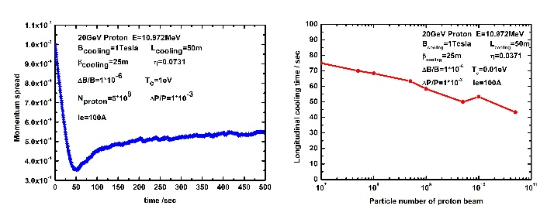
Figure 1: The momentum spread as a function of the time (left). The longitudinal electron cooling time as a function of the particle number in the proton beam (right).

Electron Beam Parameters
When the electron transverse temperature was 100 eV, the magnetic field parallelism was 1*10⁻⁵, and the electron beam current was 10 A, the proton beam was not cooled. When the electron transverse temperature was 1 eV, the magnetic field parallelism was 1*10⁻⁶, and the electron beam intensity was 10 A, the proton beam was cooled.
Parameters related to the longitudinal direction play a dominant role and are more sensitive to electronic cooling.
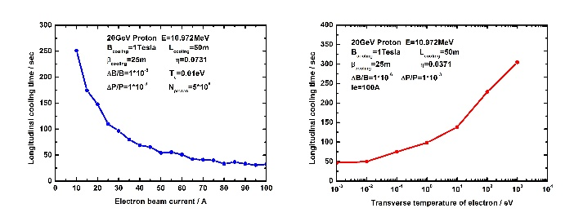
Figure 2: The longitudinal cooling time as a function of the electron beam current (left) and the transverse temperature of electron beam (right).
In order to decrease the longitudinal cooling time, the current of the electron beam and the length of the cooling section were set as a bigger value. The left diagram of Figure 2 presents the longitudinal cooling time as a function of the electron beam current. The right diagram of Figure 2 indicates the longitudinal cooling time depends on the transverse temperature of the electron beam. In the case of other parameters that were fixed, the longitudinal cooling time decreases with the increasing electron beam current and decreasing transverse temperature of the electron beam.

Magnetic Field Parameters
The left one of Figure 3 shows the longitudinal cooling time as a function of the magnetic field strength in the cooling section, and the right one of Figure 3 presents the longitudinal cooling time as a function of the parallelism of the magnetic field in the cooling section. In the case of other fixed parameters, the longitudinal cooling time decreases with the magnetic field strength in the cooling section. The longitudinal cooling time decreases with the increasing parallelism of the magnetic field in the cooling section. From Figure 3, one can see the magnetic field parallelism strongly influences the cooling time. The cooling time becomes shorter when the magnetic field parallelism is higher in the cooling section.
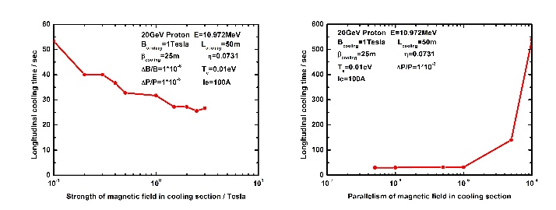
Figure 3: The longitudinal cooling time as a function of the magnetic field strength (left) and the parallelism of magnetic field (right) in the cooling section.

Electron Cooling Device Parameters
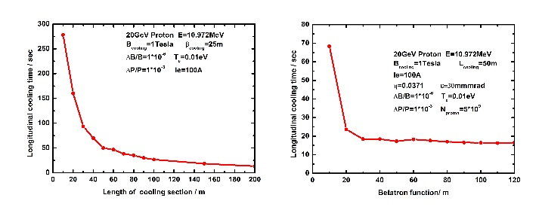
Figure 4: The longitudinal electron cooling time as a function of the length of the cooling section (left) and the Betatron function in the cooling section (right).
The left one of Figure 4 shows the longitudinal cooling time varies as a function of the length of the cooling section. In the case of other parameters that were fixed, the longitudinal cooling time decreases with the length of the cooling section. The length of the cooling section strongly influences the longitudinal cooling time. The right one of Figure 4 presents the longitudinal cooling time as a function of the Betatron function in the cooling section. The longitudinal cooling time decreases with the Betatron function in the cooling section.

Minimum and Final Momentum Spread
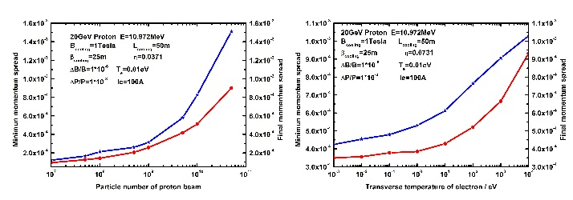
Figure 5: The minimum momentum spread and final momentum spread as a function of the particle number (left) and transverse temperature of electron (right).
The left one of Figure 5 shows the minimum and final momentum spread as a function of the particle number. The right one of Figure 5 presents the minimum and final momentum spread as a function of the transverse temperature of the electron. The minimum and final equilibrium momentum spread was mainly dominated by the particle number in the proton beam and the transverse temperature of the electron.
The left one of Figure 6 shows the minimum and final momentum spread as a function of the parallelism of the magnetic field in the cooling section. The right one of Figure 6 presents the minimum and final momentum spread as a function of the magnetic field strength in the cooling section. The minimum and final momentum spread were mainly dominated by the strength and quality of the magnetic field in the cooling section.
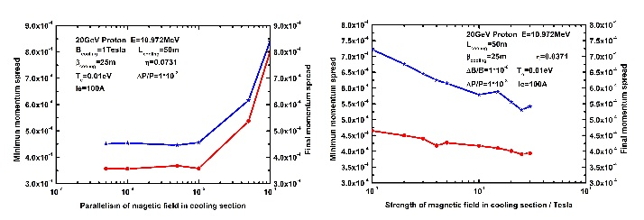
Figure 6: The minimum momentum spread and final momentum spread as a function of the parallelism of magnetic field (left) and the magnetic field strength (right) in the cooling section.

discussion
The difference in electron cooling behavior between the longitudinal and transverse directions should be investigated carefully. The reason why the proton beam was cooled first and then scattered later should be revealed clearly. In the case of high-energy conditions, the solution to solve this problem of longitudinal cooling followed by scattering should be explored.
In the case of high-energy electron cooling, the longitudinal velocity of the electron beam was much greater than the transverse velocity. In the cooling simulation, the same time interval was used for both transverse and longitudinal. Electron beams travelled at different path lengths during the same time interval in the transverse and longitudinal directions. This may be the cause of the unexpected results in the simulations.
At high energy, the longitudinal velocity of the proton beam is much greater than the transverse velocity, therefore, the deviation of the longitudinal velocity is also much greater than that of the transverse velocity. Due to longitudinal velocity mismatch or magnetic field parallelism, the projection of longitudinal velocity in the transverse direction will also be much greater than the transverse velocity of the electron beam. Therefore, in the longitudinal direction, the parameter requirements are more precise and the matching degree is high.
By the way, the cooling forces vary with the absolute value of velocity difference between electron and proton, not relative value.
Cooling force is a nonlinear force [5], and when the relative velocity is small, the cooling force is weak. When the relative speed is high, the cooling force is strong. The maximum cooling force is only achieved when the relative velocity reaches a certain value.
In electron cooling, the transverse cooling rate usually differs from the longitudinal cooling rate, especially at high energies. Dispersive cooling [6] is the way to redistribute cooling force, it can redistribute the cooling rate between longitudinal and transverse planes.

summary
From the simulated results, the longitudinal cooling time of the proton beam with 20 GeV is over 100 seconds. The longitudinal cooling time can be shortened with the help of proper configuration of the parameters, such as smaller initial emittance and electron transverse temperature, higher magnetic field strength, parallelism of magnetic field in the cooling section, longer length of electron cooling section, stronger electron beam current, and proper beta function in the cooling section.
The longitudinal cooling behavior is different from the transverse one. After the balance is achieved in the transverse direction, the emittance remains unchanged. However, the longitudinal momentum spread shrinks rapidly at the beginning and then bounces back from the bottom.
In the interest of achieving the required luminosity from physics experiments, the parameters of the proton beam, electron cooling device, and storage ring should be optimized carefully and compromise each other, and the different configurations from the point of view of realizable technical solutions.
The emittance, particle number, and longitudinal bunch length of the proton beam should be optimized and compromised carefully to obtain the required luminosity. By the way, the cooling strategy is important too, such as multi-stage cooling [7] at different energy or different periods. The emittance and momentum spread should be cooled to the required value by the stronger electron beam in the first stage, and then the smaller emittance and momentum spread will be maintained by the weaker electron beam.
High-intensity proton beam and short bunch length were expected to store in a collider with a long lifetime and less loss. To increase the lifetime of the proton beam and decrease the loss, a longitudinal hollow electron beam [8] will be attempted to suppress the intra-beam scattering. The traditional DC electron beam in the electron cooler will be modulated into shorter electron bunches with different longitudinal distributions. The stronger cooling was expected in the tail of the proton beam and the weaker cooling was performed in the core of the proton beam. The proton loss will be decreased and the lifetime will be increased. The intensity of the proton beam in the collider will be kept and maintained for a long time.
For the sake of obtaining and keeping enough particle number, smaller emittance, and shorter bunch length in the case of a proton beam with energy 20 GeV, the cooling should counteract the scattering at the different situations and periods, and provide high-quality proton beam for the higher luminosity in the storage ring. The detailed and exact simulation will be necessary for the real lattice design of the EicC storage ring in the future.

References
[1] CAO Xu, CHANG Lei, CHANG Ningbo, et al. “Electron ion collider in China”. Nuclear Techniques, vol. 43, no. 2, 2020, p. 020001-1-59. doi: 10.11889/j.0253-3219.2020.hjs.43.020001
[2] X. D. Yang, “Simulation of transverse electron cooling and IBS of 20 GeV proton beam at EicC”, in Proc. COOL2021, Novosibirsk, Russia, Nov. 01-05, 2021, pp. 70-73. doi:10.18429/JACoW-COOL2021-P1002
[3] Vasily Parkhomchuk, Ilan Ben-Zvi, “Electron cooling for RHIC”, BNL C-A/AP/47, April 2001.
[4] A.V. Fedotov, I. Ben-Zvi, Yu. Eidelman, et al, “Simulation of high-energy electron cooling”, in Proc. PAC2005, Knoxville, Tennessee, USA, 16-20, May, 2005, paper TPAT090, pp. 4251-4263.
[5] A.V. Fedotov, D.L. Bruhwiler, A.O. Sidorin, “Analysis of the magnetized friction force”, in Proc. HB2006, Tsukuba, Japan, May 29 – Jun. 2, 2006, paper WEAY04, pp. 210-214.
[6] He Zhao, Lijun Mao, Meitang Tang, et al. “Theoretical and simulation study of dispersive electron cooling”, Phys. Rev. Accel. Beams, vol. 27, p.033501, Mar. 2024. doi: 10.1103/PhysRevAccelBeams.27.033501
[7] H. Zhang, Y. Zhang, Ya. Derbenev, et al. “Multi-stage electron cooling scheme for JLEIC”, in Proc. IPAC2018, Vancouver, BC, Canada, 29 Apr.–4 May, 2018, paper MOPML006, pp. 397-399. doi:10.18429/JACoW-IPAC2018-MOPML006
[8] X. D. Yang, “Longitudinal hollow electron beam”, in Proc. IPAC2025, Taipei, Taiwan, 1-6, Jun. 2025, paper MOPS004, pp.588-591. doi:10.18429/JACoW-IPAC25-MOPS004

