THE FEATURE OF MAGNETIC FIELD FORMATION OF MULTIPURPOUSE U400R CYCLOTRON
I. A. Ivanenko^{†,1}, G. G. Gulbekian¹, J. Franko¹, V. P. Kukhtin², E. V. Lamzin², S. E. Sutchevsky²
¹JINR, Dubna, Russia
²NIIEFA, St. Petersburg, Russia

Abstract
At the present time, the activities on reconstruction of U400 to U400R cyclotron are carried out at the FLNR, JINR. The new multipurpose U400R cyclotron is intended for production of high intensity, up to 2.5 pmkA, beams of heavy ions from Helium to Uranium with mass to charge ratio A/Z= 4 – 12. The magnetic structure of the new cyclotron will provide a wide range of the magnetic field level from 0.82T till 1.82T what gives the smooth variation of accelerated beams energy 0.8 – 27 MeV/nucleon. For operational optimization of the magnetic field, the 11 radial and 2 pairs of harmonic correcting coils are used. The numerical formation of the magnetic field is carried out. The problems and solutions of U400R magnetic field design are described.

INTRODUCTION
U400 to U400R cyclotron reconstruction goals are:
- Increasing of the beam intensity up to 2.5 pmkA.
- Smooth variation of the beams energy in the range 0.8 – 27 MeV/nucleon.
- Decreasing and extending of the magnetic field range from 1.9T – 2.1T (U400) till 0.82T – 1.82T (U400R).
Figure 1: U400R cyclotron operating modes diagram.
The operating modes diagram of U400R cyclotron is shown in Fig. 1. At the diagram the lines A/Z=4 – 12 presents the isochronous accelerating modes, the lines dB=0.001T – 0.05T presents the corresponding isochronous magnetic field radial growth. The ions orbital frequency range 1.083MHz – 6.25MHz is provided by RF generator 6.5MHz – 12.5MHz and acceleration at 2 – 6 harmonics, while the cyclotron magnetic field in the range 0.82T – 1.82T provides smooth variation of the beams energy in the range 0.8 – 27 MeV/nucleon. The red dash line dB(Bo) presents the operating modes which can be realised with the isochronous magnetic fields, formed only “by iron” of chosen magnet geometry. To form the other isochronous operating modes, the block of 11 radial and 2 pair of harmonic trim coils are used. The 2nd and 11th radial trim coils have a separate power supplies for upper and lower sub coils and could be used for correcting of the beam vertical position during acceleration. The blocks of trim coils are placed in the 28mm free space between upper and lower poles and sectors.

† ivan.@jinr.ru
Table 1: Main parameters of U400R cyclotron magnet
Main size of the magnet, m | 11.4x4.2x7.3
Weight of magnet, t | 2100
Magnet power consumption, kW | 200
Magnetic field, T | 0.82 – 1.8
Pole diameter, m | 4
Pole gap, m | 0.3
Number of sectors | 4
Sector – sector gap, m | 0.056
Radial / azimuthal trim coils | 11 / 2

The reconstruction is based on U400 cyclotron compact type magnet yoke with the 4 meter diameter of the pole [1] while the other cyclotron systems will be upgraded or changed. The main parameters of U400R cyclotron magnet are presented in Table 1. The new 4 pairs of sectors and elements of magnet centre will form the required magnetic field. The numerical 3D simulation of U400R magnetic field has been carried out by using KOMPOT program package [2].

METHOD OF SECTORs SHapING
To get the isochronous form of the magnetic field the sectors could be shaped in three ways – axially from median plane side, axially from pole side and azimuthally. The method of sector shaping has strong effect on behavior of radial growth dB dependence on cyclotron magnetic field level Bo [3]. This dependence has a different nonlinear form for different methods of sector shaping.
For U400R cyclotron we choose the method of azimuthal shaping because it gives a good coincide of dB(Bo) dependence area for isochronous operating modes, marked by triangles at Fig. 2, and dB(Bo) behavior for U400R real magnetic field, red dash line at Fig. 2. It allows to minimize the total contribution of the radial trim coils and decrease their power consumption. In our case the trim coils with total contribution more than 650Gs cover all operating modes area of U400R cyclotron.
Figure 2: The radial growth dB(Bo) for operating modes area (triangles) and for real magnetic field (dash line) of the U400R cyclotron.
As the base point for numerical simulation and formation of the magnetic field only “by iron”, the operating mode 48Ca8+, Bo=1.6T, E=11MeV/nucl. was taken. The chosen base point lies at the dB(Bo) curve and at the centre of dB range of U400R operating modes area. At the Fig. 1 and Fig. 2 the base point is marked by number “1” in a circle. At the Fig.3 the comparison of the isochronous magnetic field for the chosen operating mode and the real magnetic field which was formed only “by iron” is shown. The accuracy of the numerical magnetic field formation is better than 10Gs. Other operating modes could be received by varying of the magnetic field in the range 0.82T – 1.82T and operational correction by radial trim coils.
Figure 3: The results of final numerical formation of magnetic field for the base point, operating mode 48Ca8+, Bo=1.6T, E=11MeV/nucl.
To form the isochronous magnetic field at the chosen base point, the sectors of U400R cyclotron has one side azimuthal profiling (Fig. 4).
The other side of the sectors has a straight line edge and is equipped with a removable 10-mm width plates for final correction of the magnetic field.
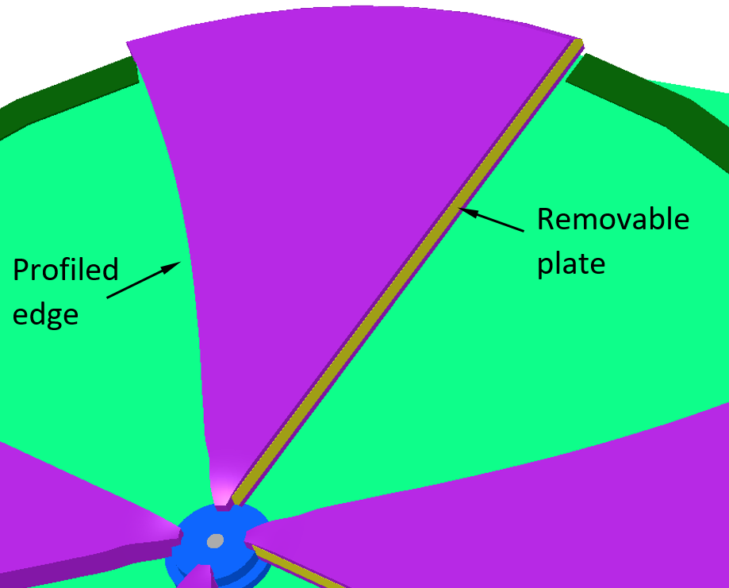
Figure 4: U400R sector structure with one side azimuthal profiling and a removable plate.

RADIAL TRIM COILS
For operative formation of the magnetic field the new U400R cyclotron is equipped with 11 radial and 2 pair of harmonic trim coils. Each coil consist of 78 turns with maximum current of power supplies up to 25A. Maximal power consumption of all trim coils is about 12kW. Trim coils are placed in a water-cooled aluminium blocks that are placed between poles and sectors.
Figure 5: The total contributions of U400R trim coils at low, 0.82T and high, 1.8T, levels of the magnetic field.
The radial positions of 11 radial trim coils are taken from formula:
$R_{i}=R_{max}\sqrt{\frac{i}{N_{max}}}$. (1)
Where Nmax =11 is a maximal number of radial trim coils and Rmax =1.8m is the radius of last coil.
The total magnetic field contributions of all 11 radial trim coils with 25A of power supply at low, 0.82T and high, 1.8T, levels of the magnetic field, are shown in Fig. 5. Circles presents the radial positions of 11 radial trim coils.

MAGNETIC FIELD AT CENTRE Region
The wide range of the magnetic field variation leads to nonlinear changing of the field radial distribution. This effect occurs because of different rate of changing of magnetic saturation in the elements of magnet. It is especially relevant for centre region elements such as central plug, sector noses and central rose. The problem of magnetic field formation in the central region is in a conflict of two purposes:
- To form the isochronous magnetic field distribution.
- To decrease the nonlinearity of the magnetic field at the different levels in the center
At the Figure 6 the difference of the final average magnetic field at 1.8T and 0.8T levels is presented. This difference has a dramatic nonlinear area in the magnet center, while the dash line presents the “ideal”, uniform changing of the field. To compensate this nonlinear behavior of the magnetic field the 1st, central trim coil is placed around central rose. Maximal contribution of the 1st trim coil is about 200Gs (Fig. 6).
Figure 6: The difference of the average magnetic field at the high, 1.8T and low, 0.8T levels. The contribution of 1st trim coil at 0.8T magnetic field level.

operationAL forming of the Magnetic field
At the base point, 48Ca8+, Bo=1.6T, the isochronous magnetic field is formed only “by iron” and no need to use the trim coils. For the operating modes that lies along dB(Bo) curve the real magnetic field is rather close to isochronous form. At this operating modes the trim coils are used only for a thin correction or to correct nonlinear errors of the magnetic field, first of all at the centre region and at the extraction radius.
If operating modes lies far away from dB(Bo) curve, their isochronous fields are formed with a deep action of trim coils. For example, at the case of variation of 48Ca8+ beam energy from 2.8MeV/nucl. till 14.4MeV/nucl., the magnetic field level must be raised from Bo=0.82T to Bo=1.8T. Corresponding operating modes are marked by number “2” and “3” in a circles at Fig. 1. Radial distribution of “iron” magnetic field are changed dramatically between this extreme operating modes and no correspond to isochronous one (Fig 7 and Fig. 8).
Block of 11 trim coils produce the needed operating correction of the magnetic field so the phase motion of the accelerated beam lies in about ±10º range.
Figure 7: Base magnetic field Bavr, isochronous magnetic field Bis, operationally formed magnetic field Bres for operating mode 48Ca8+, Bo=0.82T, E=2.8MeV/nucl.
Figure 8: Base magnetic field Bavr, isochronous magnetic field Bis, operationally formed magnetic field Bres for operating mode 48Ca8+, Bo=1.8T, E=14.4MeV/nucl.

CONCLUSION
At the present time all new elements of U400R magnet has been manufactured and is ready to install. At the beginning of 2026 the old U400 cyclotron will be decommissioned and reconstruction will start. The new U400R cyclotron magnet will provide a wide range of the magnetic field level from 0.82T till 1.8T what gives the smooth variation of accelerated beams with A/Z = 4 – 12 up to energy 0.8 – 27 MeV/nucleon.

REFERENCES
[1] Yu.Ts.Oganessian et al., “Status report of the U400 cyclotron at the FLNR JINR”, In: Proceedings of the 3th Asian Particle Accelerator Conference, 2004, Korea, pp. 52-54.
[2] B.N. Gikal et al., “The method and results of formation of the DC-60 cyclotron magnetic field”, In: Proceedings of the 18th Conference on Cyclotrons and Their Applications, October 2007, Giardini Naxos, Italy, pp. 432-434.
[3] I. Ivanenko et al., “The model of DC-72 cyclotron magnet. The research of the sector shimming methods for obtaining the working magnetic field for light and heavy ions acceleration”, In: Proceedings of EPAC 2002, October 2007, Paris, France. 2002, pp. 2349-2351.

