COMPACT BEAM ENERGY MONITOR FOR CYCLOTRONS
Z. Kormány
HUN-REN Institute for Nuclear Research, Debrecen, Hungary

Abstract
Accurately determining the energy value of cyclotron beams is challenging. Calculating it from the machine settings can only provide limited accuracy, typically with an error margin of several percent. Higher accuracy can only be achieved through measurement. Various measurement methods and systems have been developed and employed. However, each method has disadvantages: either the spatial requirements in the beam transport system are large, the unit is non-transparent (i.e. destructive), or the signal evaluation is too complicated for routine use by operator staff.
The Beam Energy Monitor (BEM) was designed to overcome these limitations and provide an ideal beam energy measurement system: compact size, non-destructive operation, low energy consumption and simple usage. This was achieved by developing an innovative sensor unit comprising two capacitive probes in a unique design, enabling accurate time-of-flight measurements to be performed on an extremely short flight path. The sensor unit's signal is acquired and processed digitally. Various digital signal processing methods were evaluated and compared with simulated probe signals to determine the most effective method of measuring the time difference between pulses. The signal processing hardware and software were tested using pulses from a high-precision signal generator. The results show that time measurements with an absolute error of less than 1 ps were achieved. The accuracy of the complete system during practical operation was investigated using neutron threshold reactions. These reactions showed that the measurement accuracy is at least one order of magnitude better than the accuracy of the energy value calculated from the cyclotron parameter settings.
The prototype unit was developed for the cyclotron at the HUN-REN Institute for Nuclear Research (ATOMKI). Installed in the main beamline, it can continuously monitor the beam energy independently from the beamline in use.

introduction
Cyclotrons usually perform poorly when deriving beam energy from machine parameter settings. This is essentially due to a lack of knowledge about the true position of the orbit centre at extraction, meaning the final radius is not exactly known. Therefore, the nominal extraction radius is used as the final one in the energy calculation formula, resulting in an energy value that may differ significantly from the true value. In the case of cyclotrons, the error of such calculations is usually in the order of a few percent [1, 2].
Of the methods developed for measuring beam energy, time-of-flight (TOF) systems are superior in several respects. Unlike magnetic systems, they measure a quantity that is directly proportional to the velocity and energy of the accelerated particles. Conventional TOF systems use two or three sensors built independently at different locations in the beam transport system. Achieving errors at the tenth of a percent level requires a rather long flight time due to existing inaccuracies in the known differences in delay times between the signal paths. Therefore, a large distance between the sensors is needed. Consequently, such systems require large space in the beam transport system and can be installed and used only in dedicated beamlines.

Design of the new device
The BEM takes a different approach: two sensors are arranged close to each other within a common mechanical structure. This new design offers a unique advantage over conventional systems: the particle beam can pass through the device in both directions as the device can be reversed longitudinally in the beam transport system. Measuring the time difference between pulses when transporting the same beam through the device in two directions enables the delay difference in the signal paths to be determined. Once this value is known, the measured time difference can always be corrected to obtain an accurate time-of-flight value. This reduces the systematic error in time measurement and enables high accuracy to be achieved despite the short flight path.
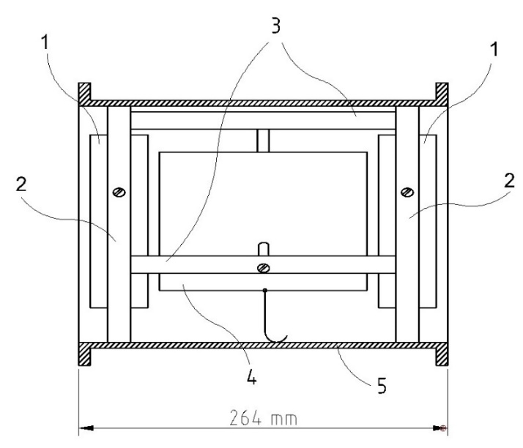
Figure 1: Conceptual structure of the BEM sensor unit: 1 - capacitive probe, 2 - centring insulator, 3 - spacer, 4 - grounded electrode and 5 - vacuum chamber.
Figure 1 shows the conceptual structure of the sensor unit, including its main components inside the vacuum chamber. The two cylindrical capacitive probes are 5 cm long and have an inner diameter larger than that of the beam pipe. This prevents the beam from hitting them directly. The probes are mounted on a support structure consisting of insulators and spacers. The distance between the probes (the flight path length) is defined by the spacers and is only 20 cm. A grounded cylindrical electrode with an inner diameter equal to that of the beam pipe is placed between the probes. This electrode provides longitudinal geometrical and electrical symmetry on both ends of the probes. This unique construction [3] makes it possible to measure the time-of-flight value, and thus the beam energy, with high accuracy despite the short flight path and longer beam bunches. The vacuum chamber itself is only 26.4 cm long, and including the connecting flanges and beam pipe sections, the entire sensor unit occupies less than 40 cm of longitudinal space in the beamline.
The capacitive probes' signals are added in the unit by an RF power combiner. Combining the signals from both probes into a single signal provides significant benefits for the system. Having just one signal path from the sensor unit to the measurement electronics enables modifications to be made freely (e.g. the cable can be disconnected and reconnected, or a new preamplifier can be used), as no change to this path can affect the time difference between the pulses. Such a sensor unit can easily be relocated and used in another beamline, or even at a different accelerator. As long as the time of flight of the beam bunch is longer than the length of the bunch, the output waveform of the RF combiner still shows separated beam pulses. However, due to the unit's compact size, the time-of-flight value between the probes can be shorter than the length of the pulses generated by the beam bunches on the probes. Therefore, the proper time difference between the pulses is ensured by delaying the signal from the second probe prior to addition. The exact value of the difference in signal delay between the probes is determined by calibration. This value is then subtracted from each measured time difference between the pulses in order to calculate the time of flight.
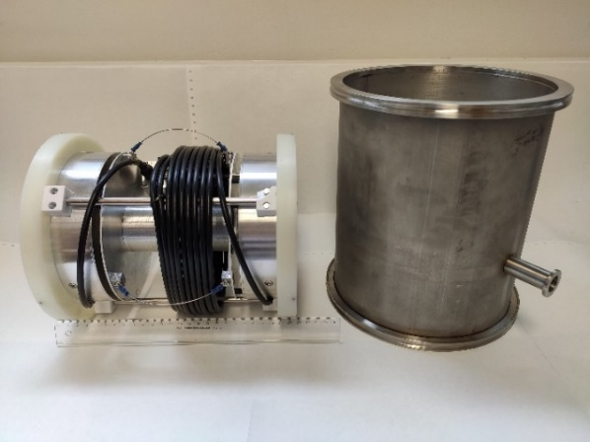
Figure 2: Sensor unit and its vacuum chamber.
Figure 2 shows the sensor unit and its vacuum chamber. The capacitive probes are designed with a 50-ohm geometry. The spacers are fixed to the outer electrode of the probes using insulators. The support structure is made of Invar and Macor to minimise changes in flight distance due to temperature variations. The actual distance between the probes was measured with high accuracy using a coordinate measuring machine. The absolute error of 5 µm achieved in the probe-to-probe distance translates into a relative error in the flight path length of 2.5×10⁻⁵, which is completely negligible. Therefore, the error in the beam energy measurement depends solely on the accuracy of the flight time determination.

Digital signal processing
The signal from the sensor unit is digitally evaluated. The analog probe signal is amplified and acquired by a digital oscilloscope with a sampling rate of 5 GS/s. The cyclotron bunches are typically several nanoseconds long; therefore, several tens of samples are available in real-time sampling (RTS) mode. Various signal processing algorithms can be employed to determine the distance between digitally sampled pulses. Auto-correlation and the least squares norm (L2Norm) use all N samples of pulses S₁ and S₂, rather than just one sample or part of them (e.g. the falling edge):
$$C\left(j\right)= \sum_{i=1}^{N}{S_{1}}\left(i\right)*S_{2}(i+j)$$
$$L2\left(j\right)= \sum_{i=1}^{N}{{\left[S_{1}\left(i\right)-S_{2}(i+j)\right]}^{2}}$$
The two functions reach their extremes when the pulses S₁ and S₂ overlap; the correlation has a maximum and the L2Norm has a minimum at this shift index (j). The algorithms were tested and compared using simulated probe signals with the GNU Octave software package [4]. When calculating these functions, pulse S₂ can only be shifted by an integral multiple of the sample period (i.e. only integer j values are permitted). To improve the resolution, polynomial functions were fitted to the calculated values using the least-squares method within an interval centred on the extreme. Due to the observed symmetry, only even functions are appropriate. The width of the interval (i.e. the number of points to be considered) and the order of the polynomial function were both varied. It was found that a quadratic function with an interval of three to five points on either side of the extreme was optimal; higher-order polynomials or fitting intervals with more points did not noticeably improve the accuracy.
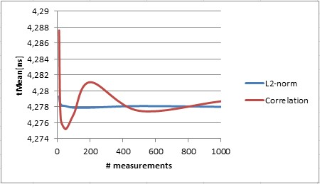
Figure 3: Simulation results for an assumed time difference of 4.278 ns between the pulses.
Due to quantisation noise in finite-width analog-to-digital conversion, the measured time difference between pulses fluctuates. This effect can be mitigated by calculating the statistical mean of multiple individual measurements, given that the mean values of thermal and quantisation noise are zero. Figure 3 shows the results of these calculations for an assumed time difference between the pulses. The mean values of the L2Norm measurements deviate less from the actual time difference and are much more stable. Another advantage of this method is that the same level of accuracy can be achieved by calculating the mean value from fewer individual measurements. Consequently, the L2Norm algorithm was chosen for measuring the time difference between the pulses.
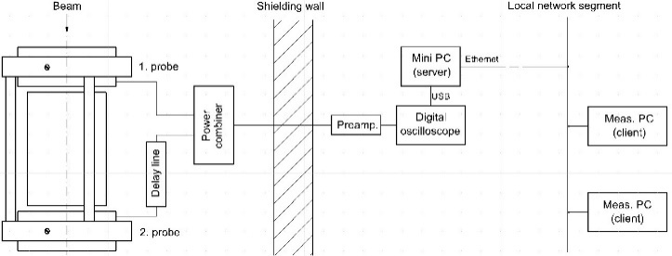
Figure 4: Setup of the measurement system.

system electronics
Figure 4 shows the measurement system setup. To minimise cable attenuation, the system electronics were placed outside the shielded area, as close as possible to the sensor unit. The electronic hardware consists of three main parts: a broadband preamplifier (~40 dB), a USB digital oscilloscope (PicoScope 6403C), and a mini PC (Intel NUC). The mini PC with Linux Ubuntu operating system runs the server program that controls the digital oscilloscope and reads in the acquired waveforms. After some preprocessing, it sends the waveforms and other requested data to all connected clients on the same local network segment.
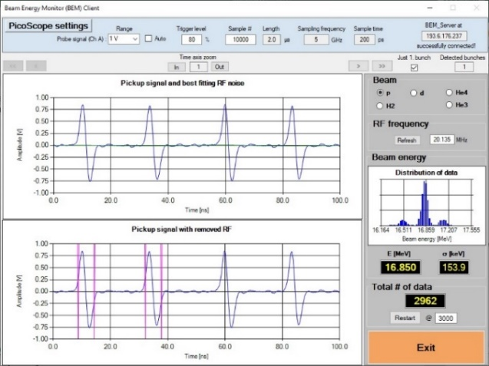
Figure 5: Screenshot of the measurement program.
The measurement program can be run on any Windows PC within the same network segment. Once connected, it regularly requests and receives waveform data from the server program and evaluates them. Numerous tests have shown that averaging around 3,000 individual time measurements suppresses fluctuations below 0.1–0.2 ps. Therefore, the mean of 3,000 individual measurements is considered to be a new beam energy value. The measured energy values are logged and displayed continuously on a chart in an Excel workbook. Figure 5 shows a screenshot of the measurement program when a proton beam with a nominal energy of 17 MeV was accelerated. The calculated value differs from the measured value of 16.850 MeV by 150 keV (~1 percent), which is fairly typical for the calculations.

Accuracy
The accuracy of the signal processing hardware and software was tested using repetitive 5-ns-long pulses from a high-precision RF signal generator. The period length of the pulse stream was varied over a broad interval. The average time measurement error was found to be 0.2 ps, with a maximum error of 0.6 ps. In the worst-case scenario, the energy measurement error does not exceed 10⁻³ provided the flight time remains above 1.2 ns. With the current flight distance of 20 cm, this condition is met up to a proton energy of 190 MeV.
The full system's accuracy was tested in practical operation using well-known neutron threshold reactions [5]. The ¹³C(p,n)¹³N and ²⁷Al(p,n)²⁷Si reactions were used for this purpose; these reactions have threshold energies of 3235.7 ± 0.7 keV and 5804.3 ± 0.2 keV, respectively. The measured beam energy values differ by 2.5 keV and 14.3 keV from the expected values, corresponding to relative energy measurement errors of ∆E/E = 8.3×10⁻⁴ and 2.5×10⁻³, respectively.

Conclusion
The Beam Energy Monitor is a new diagnostic tool offering many advantages for measuring and monitoring the energy of accelerated particle beams. Compact and easy to install, even in short beamlines, it is as accurate as more complicated energy measurement systems and simple enough for the operator staff to use it routinely. The prototype device was developed at the HUN-REN Institute for Nuclear Research and is installed in the main beamline of the ATOMKI cyclotron. As it is non-destructive, this installation enables continuous monitoring of the beam energy, regardless of which beamline is actually used.
The Beam Energy Monitor has been commercialized and is available from ionEM Kft. [6].

REFERENCES
[1] J. W. Burrage, et. al., “A simple method to measure proton beam energy in a standard medical cyclotron”, Australasian Phys. & Eng. Sciences in Med. vol. 32, no. 2, pp. 92-97, 2009.
[2] A. M. Hendy, F. M. Alrumayan, H. A. Kassim, and K. Kezzar, “High accuracy cyclotron beam energy measurement using cross-correlation method”, in Proc. Cyclotrons'16, Zurich, Switzerland, Sep. 2016, pp. 193-195.
doi:10.18429/JACoW-Cyclotrons2016-TUP12
[3] Z. Kormány, “Method and apparatus for measuring and monitoring the energy of charged particle beams of cyclic accelerators”, Hungarian Intellectual Property Office (HIPO), PCT/HU2025/050012, Mar. 4, 2025.
[4] GNU Octave, www.octave.org
[5] Z. Kormány, L. Csedreki, “Verification of the accuracy of a compact beam energy monitor”, Nucl. Instrum. Methods Phys. Res. A, vol. 1076, July 2025, 170483. doi:10.1016/j.nima.2025.170483
[6] ionEM Kft., www.ionem.hu

