Project status and R&D efforts for Super Tau-Charm Facility
Jingyu Tang† on behalf of the STCF team
University of Science and Technology of China, Hefei 230026, China

Abstract
The Super Tau-Charm Facility (STCF) was proposed as a third-generation circular electron-positron collider in the energy range of 2-7 GeV (CoM) and with a luminosity greater than 5×10³⁴ cm⁻²s⁻¹ @4 GeV, aiming to explore charm physics and tau physics in the next decades. This paper introduces the facility design and ongoing R&D efforts for STCF, covering the design goal, accelerator and detector schemes, and key technological R&D efforts, with a particular focus on the accelerator. Supported by a key technology R&D project funded by the local governments and other national funding agencies, the STCF accelerator team including international collaborators has completed the conceptual design of the accelerator, and initiated the technical design. The accelerator comprises of a full-energy injector consisting of multi-section linacs and a positron accumulator ring and a double-ring collider with the crab-waist collision scheme. Key physics and technological challenges will be addressed. This paper also summarized ongoing R&D progresses and outlines future project planning.

Introduction
STCF was conceived around 2011 as the succesor to the currently operational BEPCII collider, aiming to explore rich physics in the tau-charm energy range over the next three decades [1]. As a circular electron-positron collider, it operates at a low but wide energy range of 2-7 GeV (center-of-mass energy), with a super high luminosity of 5×10³⁴ cm⁻²s⁻¹ @4 GeV or about two orders higher than that of BEPCII. STCF is being designed as a new-generation circular electron-positron collider employing the crab-waist collision scheme.
In 2023, a study team was formed to carry out the design and technological R&D of the STCF, hosted by University of Science and Technology of China (USTC) with broad participation from institutions across China. Major financial support has been provided by the local governments of Anhui Province and Hefei City, with additional support from the Chinese Academy of Sciences (CAS), National Natural Science Foundation of China (NSFC), Ministry of Science and Technology (MoST) and USTC. Currently, the project has been recommended by the CAS to the central government for starting the construction in the 15th Five-Year Plan period (2026-2030).
The collider will be built in Hefei, Anhui Province, adjacent to the four-generation light source - HALF (currently under construction). Both facilities are core components of the Hefei Comprehensive National Science Center.

†jytang@ustc.edu.cn

Accelerator frame
As a new-generation or third-generation electron-positron collider, the STCF accelerator complex is required to deliver extremely high luminosity [2]. This goal is particularly challenging given the continuous and wide CoM energy range of 2-7 GeV. The accelerator consists of two major compenents: the two-ring collider and the injector. The collider rings, one electron ring and one positron ring, will operate in top-up injection mode to achieve high integral luminosity. Currently both conventional off-axia injection and the more advanced swap-out injection are under consideration. For the latter, each injection must provide as much as 8.5 nC for both electron and positron bunches. Considering the very short beam lifetime in the collider rings, in particular in the low beam energy region of 1-2 GeV, these requirements neccssitate that the injector provide full-energy electron and positron beams with high-repetitaion rate, with a variable beam energy of 1-3.5 GeV and a different bunch charge of 1-8.5 nC.
The acceleration of the electron beam is straightforward by using conventional S-band linacs at 2.998 GHz. The positron beam is generated by bombarding a high-energy and high-charge electron beam onto a tungsten target. After capture and initial acceleration, the positron beam of very large emittance and momentum spread will be sent to a damping ring for improving the beam quality. An injector scheme that is compatible with both off-axis injection and swap-out injection has been adopted, and further details are provided in the injector section. Figure 1 shows the general layout of the accelerator complex. Table 1 lists the key design goals of the STCF accelerator.
Table 1: Design Goals of the STCF Accelerator
Parameter | Value
Center-of-mass energy (GeV) | 2-7
Luminosity @ 4 GeV (cm⁻²s⁻¹) | 5×10³⁴

design of the collider ringS

Layout and lattice design
The collider rings adopt a hexagon-like layout, featuring four main arcs with 60° bending and four short arcs with 30° bending [3-4]. The Interaction Region (IR) is located in the middle of one pair of short arcs, while the crossing region of the two rings is situated on the opposite side. Four long straight sections serve the following functions: injection/extraction, damping wigglers, RF stations and collimation; the two additional long straight sections near the IR are used for optics matching. The layout is illustrated in Figure 2. The main parameters are summarized in Table 2.
FODO cells with a 90° phase advance are used for the arc sections. Chromaticity correction and nonlinear optimization in the arc sections are achieved using sextupole magnets, which are placed in pairs with a phase advance of 180°, thereby satisfying the −I transformation condition.

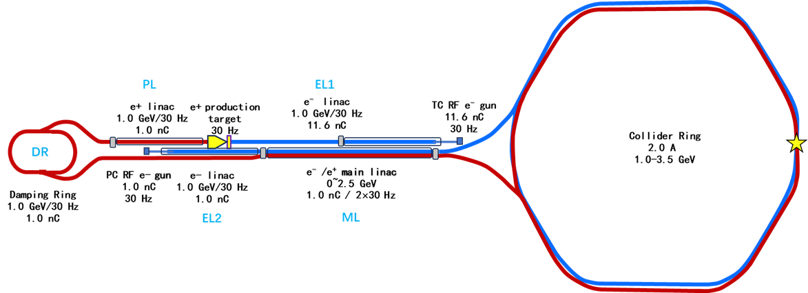
Figure 1: Schematic of the STCF accelerator.

Table 2: Main Parameters of the Collider Rings
Parameters | Units | Value | Value | Value
Beam energy | GeV | 2 | 1 | 3.5
Circumference | m | 825.524
Crossing angle | mrad | 60
L* | m | 0.9
Ratio, ε_{y}/ε_{x} |  | 1% | 1% | 0.5%
ε_{x} with DW/IBS | nm | 3.93 | 6 | 27
$$β_{x}^{*}$$ | mm | 40 | 40 | 100
$$β_{y}^{*}$$ | mm | 0.8 | 2 | 2
Beam current | A | 2 | 0.8 | 2
Bunch filling ratio |  | 48%
Single-bunch charge | nC | 8.34 | 3.34 | 8.34
SR power per beam | MW | 1.25 | 0.1 | 2.99
RF frequency | MHz | 499.7
RF voltage | MV | 2.5 | 0.75 | 6
$$ξ_{y}$$ |  | 0.100 | 0.093 | 0.049
Touschek lifetime | s | 364 | 267 | 10972
Luminosity | cm⁻²s⁻¹ | 1.0E+35 | 8.0E+33 | 3.3E+34

The IR is designed to provide very small $β_{y}^{*}$ and $β_{x}^{*}$ to achieve extremely high luminosity with a large crossing angle of 60 mrad. The crab-waist collision is realised by placing sextupoles at appropriate phase advance from the interaction point (IP). An IP Modular lattice scheme has been adopted to accomodate the requirements of multiple functions: a strong final focusing telescope (FFT), local vertical chromaticity correction (CCY), local horizontal chromaticity correction (CCX), crab sextupoles (CS) and local matching sections (MCY/YMX/XMC) and a matching section (MS) to the long straight section [5]. The layout is illustrated in Figure 3.
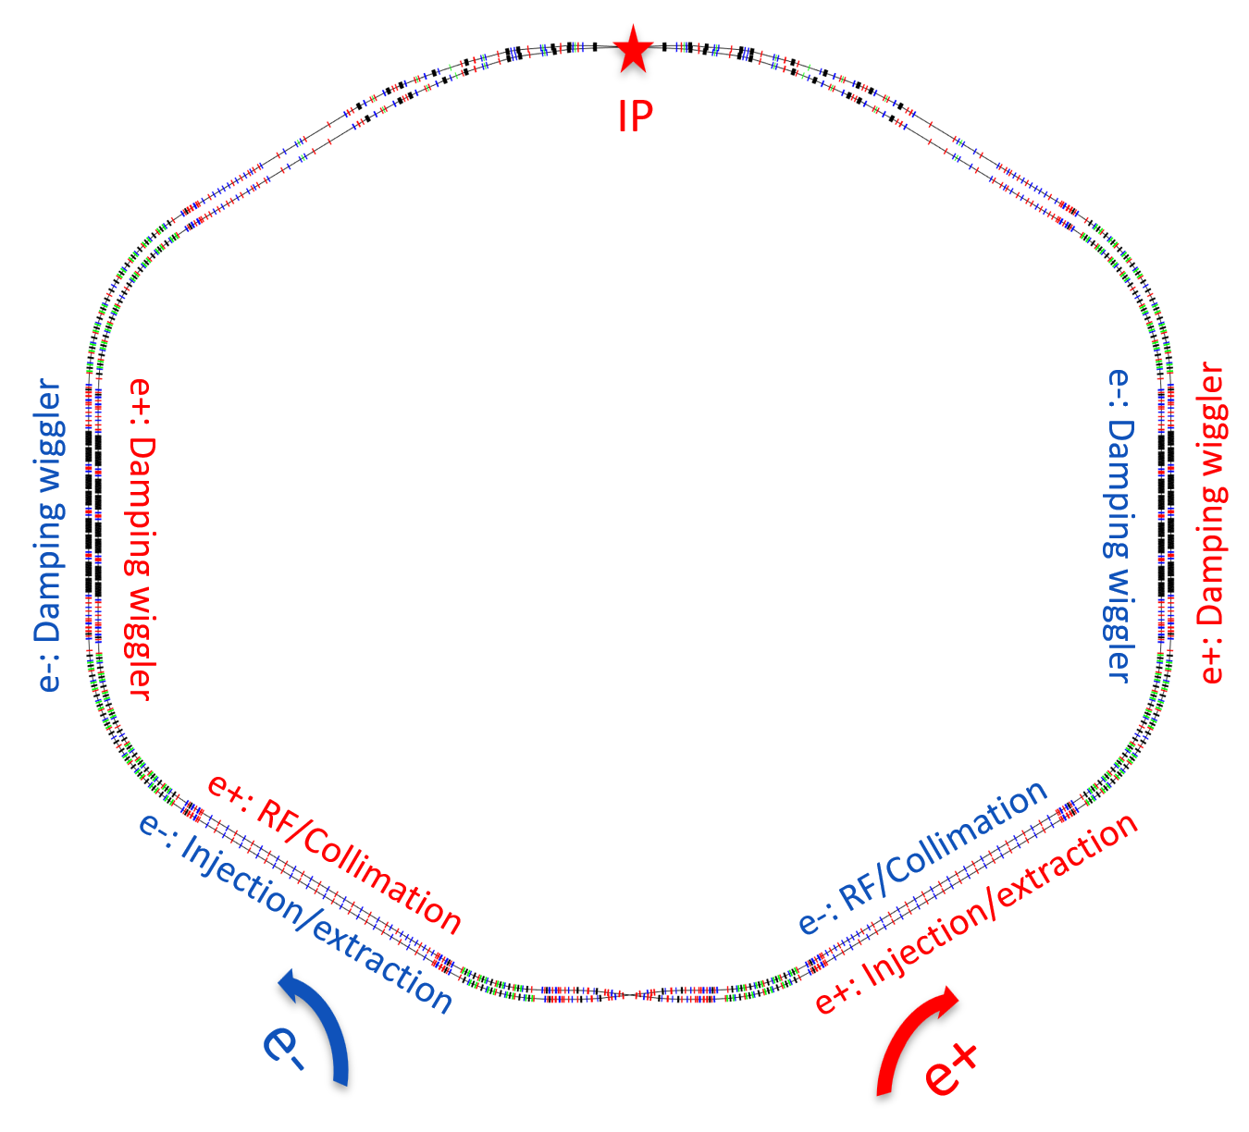
Figure 2: Layout of the collider rings.

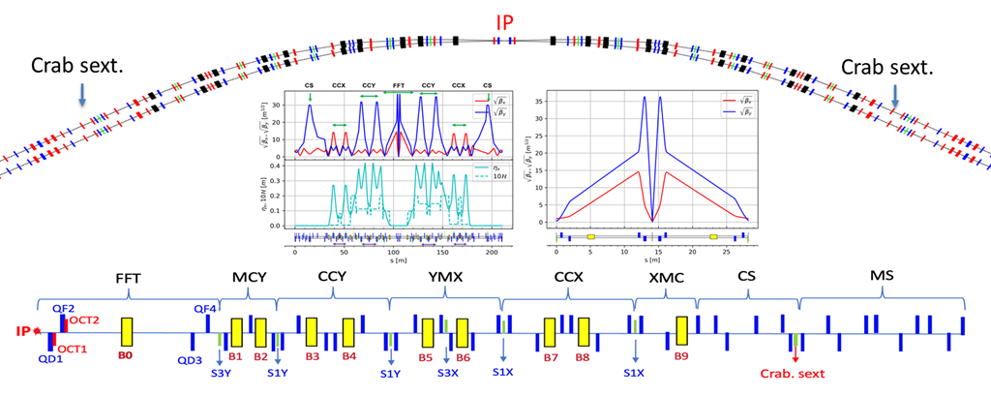
Figure 3: Layout of the collider rings.

The lattices for the long straight sections are flexible, tailored to their special functions, with triplet cells employed in the damping wiggler and RF stations sections to provide long drifts.

Key physical problems in the collider rings
As a new-generation e+/e- collider, the collider rings face numerous challenges in physics design [6-8]. Here are brief introduction to some of them:
(1) Very strong nonlinearities in the IR, which arise primarily from the local chromaticity correction sextupoles, the fringe fields of the final focus (FF) quadrupoles, the higher-order kinematic terms and the crab sextupoles. These nonlinearities will cause severe reduction of the dynamic aperture (DA) and local momentum aperture (LMA), and ultimately shortening the Touschek lifetime to as low as about 300 s at energies below 2 GeV.
(2) Unconventional beam-beam effects associated with the crab-waist collision scheme. With a large crossing angle at the IP, crab sextupoles have proven effective in suppressing the coupling instabilities between the two transverse planes (X/Y) and as well between the transverse and the longitudinal planes (X/Z). However, the interplay among several physical mechanisms such as injection, impedance, nonlinear lattice, space-charge must be taken into account, which makes the study very complicated.
(3) Beam injection with very small DA and LMA, combined with a very short lifetime. The conventional off-axis injection method faces the problem of low injection efficiency, especially when the wide energy range of 1-3.5 GeV is taken into account. The swap-out injection method is applicable for very small DA, but it requires a much powerful injector to provide a bunch charge as high as 8.5 nC per injection. Moreover, regradingless of which injection method is adopted, top-up injection must be performed continuously to match the beam lifetime, e.g. at a rate of about 30 Hz in the lower energy region of 1-2 GeV.
(4) Beam loss due to very short lifetime and collimation. Owing to the very high circulating beam current of 1-2 A, low emittance of about 5 nm and small DA/LMA in the low energy region, the Touschek scattering is extremely severe and resulting in an unprecedented short lifetime for any type of electron storage ring, in some cases less than 300 s. This implies a high beam loss rate. Furthermore, in addition to the usual concern of radiation dose rate in the tunnel and protection of key accelerator components such as superconducting magnets, the experimental background caused by beam losses at the IP is a critical issue for the collider. A sophisticated beam collimation system must be designed to address the problem. However, the impedance of the collimators remains a key challenge in colliders.

Technological challenges in the collider rings
To meet the requirements from the physics design of the collider rings, several technical systems have been identified as crucial and challenging. Some of the most challenging technologies are described below.
With a large crossing angle of 60 mrad and a short L* of 0.9 m, the superconducting quadrupoles for the final focus are designed using the CCT (canted cosine-theta) technique with a twin-aperture configuration. Combined with the requirements of a high-field gradient of 50 T/m, high field quality, and extremely tight spatial constraints, these magnets are considered highly challenging within the community. Moreover, the same cryostat housing the quadrupoles also contains shielding and compensation solenoid coils to minimize the influence of the detector solenoid field, as well as multi-order correction coils to correct nonlinear fields and orbit deviation. As a result, the whole cryomodule becomes very complex.
The vacuum system of the collider rings presents another challenge, primarily due to the requirement of very low dynamic pressures (<1×10⁻⁷ Pa at the IR and <5×10⁻⁸ Pa elsewhere) and the extremely high synchrotron radiation power at the arcs, about 17 kW/m at the highest locations when operating at 3.5 GeV. Good vacuum is essential for suppressing the experimental background arising from beam-gas scattering and beam instabilities. These requirements necessitate special designs for the vacuum chamber structures, pumping methods and cooling methods.
The challenges for the ring RF system are: very high RF power (exceeding 300 kW per cavity), deep HOM damping and a low R/Q value. Room-teperature cavities operating in the TM020 mode have been adopted. However, the RF power requirement is unprecedented for this new type of cavity, which was first used at NanoTerasu [9], and necessitates special design and development of the RF couplers.

design of the injector
The baseline design of the injector consists of four linacs, one positron damping ring (DR), and five major transport lines [10]. The layout is shown in Figure 1. The injector is designed to support top-up injection of electron and positron beams of 1.0-3.5 GeV into the collider rings using conventional off-axis injection, with a maximum bunch charge of 1.0 nC. However, the injector layout allows for easy upgrades to provide electron and positron beams with a maximum bunch charge of 8.5 nC for swap-out injection.
For direct injection of the electron beam, an L-band photocathode electron gun is used, then the beam is accelerated to 1.0 GeV by a low-emittance linac (EL2). For the positron beam, a thermionic electron gun is used to provide very high bunch charge of 11.6 nC, and the beam is accelerated to 1.0 GeV by EL1 before bombarding a tungsten positron target. The positron beam is formed by a capture system of the AMD (Adiabatic Matching Device) and large-aperture accelerating structures, then accelerated to 1.0 GeV in the positron linac (PL) [11]. The DR reduces the transverse and longitudinal emittances. The main linac (ML) alternately accelerates the electron beam from EL2 and the positron beam from DR with a maximum repetition rate of 60 Hz (30 Hz +30 Hz) to energies of 1.0-3.5 GeV. The transport lines transfer the e-/e+ beams connecting the linacs to DR, and injecting the beams from ML to collider rings, where transverse and longitudinal matchings are needed while maintaining low emittance growth.

Linac designs
EL1 is a traditional S-band electron linac, equipped with a thermionic electron gun, sub-harmonic bunchers. Its main challenge lies in handling the very high bunch charge of 11.6 nC.
EL2 is similar to an electron linac used for X-ray free electron lasers. It is equipped with an L-band photocathode electron gun, a chicane section to compress the bunch length, and a low-emittance linac. The main challenge is to maintain low-emittance while accelerating high-charge bunches for the swap-out injection.
PL is quite different from conventional electron linacs. Its front-end sectiont is designed to capture positrons with an extremely large momentum range and large transverse emittance. Therefore, a large-aperture accelerating structure with a diameter of 30 mm is used, instead of the usuaul 20 mm for standard linacs.
ML is an energy-variable linac, capable of operating from no-acceleration (1.0 GeV) to a maximum acceleration of 3.5 GeV, and is designed to accelerate alternately two opposite charged beams with high-bunch charge [12]. Its lattice is based on triplet focusing cells.

Positron damping ring
DR has a racetrack layout with a circumference of 152.4 m, as shown in Figure 4. The lattice is based on a FODO + Reverse Bend configuration to shorten the damping time (23 ms in the transverse planes) and provide the low equilibrium emittance (H: 9.62 nm.rad, V: 0.1 nm.rad) [13]. The two long straight sections are for injection, extraction and hosting two RF cavities. The dipole magnets adopt a hybrid structure with permanent magnet blocks to save the power supplies.
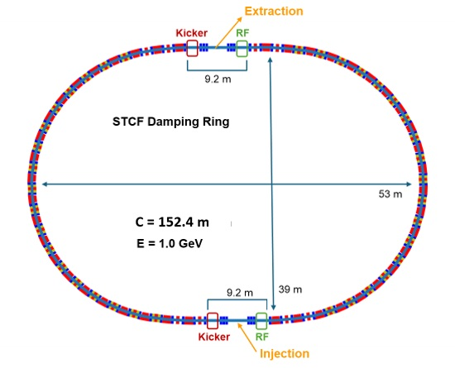
Figure 4: Layout of the positron damping ring.

Technology R&D efforts
The STCF accelerator poses many technological challenges. In particular, the superconducting magnets at the IR, the ultra-high vacuum chambers facing extremely high synchrotron radiation, and the RF cavities demanding very input high power/deep HOM damping/a low R/Q value, are all beyond the state-of-the-art and are the most critical. Nevertheless, steady progress is underway in the development and prototyping of these key technologies.

IR superconducting magnets
The superconducting quadrupole doublets (FF quadupoles) are key to archieving a very small
$β_{y}^{*}$ of ≤1 mm. Due to the large crossing angle of 60 mrad and a very short L* of 0.9 m, they must be of twin-aperture design. However, the extremely tight space resulting from the small separation of the two beams, combined with the high field gradient of 50 T/m and stringent field quality requirements, makes these magnets exceptionally challenging to design and fabricate. In addition, a large number of solenoid coils are needed to shield the FF quadrupoles from the field of the detector solenoid and compensate its integral field in other part of the IR. As a result, the entire IR superconducting magnet system is very complex.
A prototype of the QD1 quadrupole (the closest to IP, shown in Figure 5 ) based on the CCT technique, has been built and tested [14-15]. The field measurement show that the field quality is satisfactory and consistent to the design specifications. In the next stage, a full-scale prototype of the IR superconducting magnet module will be built and tested.
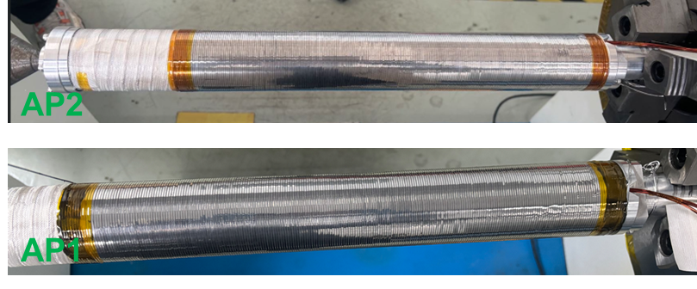
Figure 5: A pair of the prototype units for the FF quadrupole (QD1, CCT type) before assembling.

Vacuum in the collider rings
To suppress the experiment background at the IP arising from beam-gas scattering and collective beam instabilities, the dynamic vacuum pressure in the collider rings is designed to be as low as 5×10⁻⁸ Pa, with a static pressureof approximately 5×10⁻⁹ Pa. Meanwhile, the unprecedented high synchrotron radiation power density of 17 kW/m at its peak in the arcs - corresponding to the e-/e+ beams at 3.5 GeV and 2 A, poses significant challenges for the design of the vacuum chambers, particularly in terms of cooling. A vacuum model of an arc cell as shown in Figure 6 , is currently being designed and fabricated, and a photon absorber of accepting 17 kW as its most challenging part is already in fabrication.
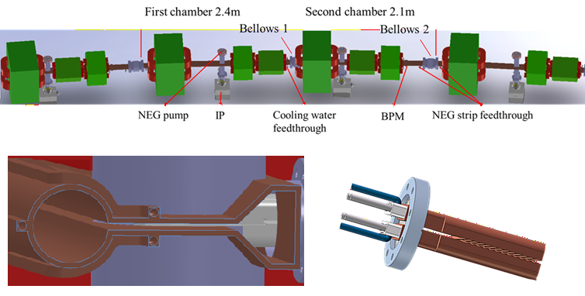
Figure 6: Model of one arc vacuum cell of the collider rings (upper), the cross-section and a photo absorber under prototyping (lower).

RF cavities in the collider rings
The RF system in the collider rings must deliver a maximum RF power of 3 MW to the beams to compensate for synchrotron radiation loss. The cavities are required to have deep HOM damping and a low R/Q value to avoid beam instabilities. A room-temporature RF cavity type operating in the TM020 mode has been adopted, a design first developed and used in Japan. However, the requirement for STCF is even more demanding in terms of input RF power, with 300 kW per cavity. A prototype of the cavity has been built and is currently undergoing high-power test to master the fabrication techniques [16-18], see Figure 7.
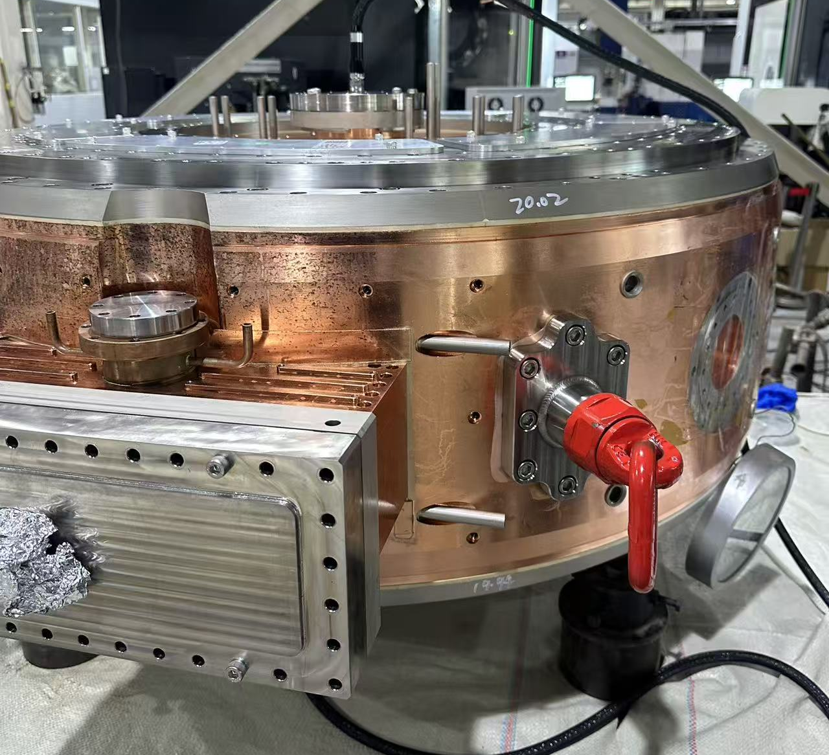
Figure 7: A prototype of the room-temperature TM020 RF cavities for the collider rings.

project status and outlook
The STCF project aims to complete the first-phase of R&D and the Technical Design Report (TDR) by October 2026. All designs and prototypes must pass the acceptance reviews to fulfill the R&D project supported by the local governments. If the construction application for the 15th Five-Year Plan is approved by the central government, a new round R&D will commence shortly thereafter, with groundbreaking anticipated in 2028. In the meantime, the feasibility study report and engineering design report must be submitted to the relevant authorities within a short timeframe. Should approcal not be granted, a low profile approach will be adopted, constinuing the design and less-intensive key technology development while awaiting the next approval opportunity.

Acknowledgements
Thanks to all the STCF team members for all the efforts in the last three years. This work is jointly supported by National Natural Science Foundation of China (No. 12341501), and Hefei Comprehensive National Science Center.

REFERENCES
[1] H. Peng, Y. Zheng, X. Zhou, Super Tau-Charm Facility of China. Physics 49, 513 (2020).
[2] Xiao-Cong Ai, Liu-Pan An, Shi-Zhong An et al., Conceptual design report of the Super Tau-Charm Facility: The accelerator, Nucl. Sci. Tech. 36, 242 (2025).
[3] Y. Zou, L. Zhang, T. Liu, et al., Optics design of the Super Tau-Charm Facility collider rings, Nucl. Instrum. Methods Phys. Res. A, 1084 (2026) 171191.
[4] Y. Zou, L. Zhang, T. Liu, et al., An updated physical design for the STCF collider rings, Proc. of IPAC2026, Deauville, France, (2026), WEP1603, this conference.
[5] L. Zhang, Y. Zou, T. Liu, J.Y. Tang, Nonlinear chromaticity correction for the interaction region of Super Tau-Charm Facility, Proc. of IPAC2026, Deauville, France, (2026), WEP1601, this conference.
[6] T.L. He, Y. Zou, D. Zhou, et al., Impact of coherent wiggler radiation impedance in Tau-Charm factories, Phys. Rev. Accel. Beams, 28 (2025) 101002
[7] L. Zhang, T. Liu, S. Li, et al., Longitudinal beam dynamics and collective effects at the STCF collider rings, Modern Physics Letters A, Vol. 39, 24440008 (2024)
[8] S. Li, D. Zhou, L. Zhang, et al., Investigating luminosity optimization in STCF with crab waist scheme by beam-beam simulation, Modern Physics Letters A, Vol. 39, 2440013 (2024).
[9] H. Ego, H. Tanaka, T. Inagaki et al., Compact HOM-damping structure of a beam-accelerating TM020 mode rf cavity. Nucl. Instrum. Meth. A 1064, 169418 (2024).
[10] D. Gu, Y.C. Xie, D.Z. Huang et al., Design progress of STCF injector，Proc. of IPAC2026, Deauville, France, (2026), WEP1610, this conference.
[11] S.T. Teng, H. Hu, T.N. Hu et al., Physical design of the main linac section for electron beam in the STCF injector, Proc. of IPAC2026, Deauville, France, (2026), TH5603, this conference.
[12] X. Xin, A.L. Zhang, G.X. Pei, et al., Design of the positron accelerators for STCF. Journal of Instrumentation, JINST 20, T03003 (2025).
[13] X. Yang, R. Huang, B. Zhang, et al., Low emittance beam transport system of the positron damping ring for the Super Tau-Charm Facility, Proc. IPAC2026, WEP1623, Deauville, France, (2026), this conference.
[14] W. Ma, S. Wei, Z. Chu et al., Development of Interaction Region Superconducting Magnet Twin-Aperture Final Focus Quadrupole Prototype for Super Tau-Charm Facility, IEEE Trans. on Applied Supercon., Vol. 36, No. 5, (2026) 4004605,
[15] W.B. Ma et al., Design and construction of the twin-aperture superconducting quadrupole magnets prototype for the STCF interaction region, Proc. IPAC2026, TUP7657, Deauville, France, (2026), this conference.
[16] C.Z. Wang, Y.L. Wei, L. Sun et al., Design of a 500 MHz TM020-mode cavity with elliptical choke for the high-current Super Tau-Charm Facility, Nucl. Sci. Tech., 37, 85 (2026).
[17] C.Z. Wang, L. Sun, Z.C. Huang et al., A TM020-mode cavity with choke geometry for the Super Tau-Charm Facility, Proc. of IPAC2025, Taipei, Taiwan, (2025), WEPB108.
[18] C.Z. Wang, Z.C. Huang, L. Sun et al., Design, fabrication, and test of a TM020-mode cavity with elliptical choke for Super Tau-Charm Facility, Proc. of IPAC2026, Deauville, France, (2026), TUP7609.

